ORDER GUIDE COMPARE
Beginner’s User Guide
Replacing the side-by-side paper comparison of GM order guides with jev-diff
Who this is for: anyone who has been comparing last year’s and this year’s order guide by printing both, laying them side by side and marking the differences with a highlighter. No programming knowledge is needed.
What you will be able to do by the end: produce a full list of what changed between two model years in a few minutes, work through it from most important to least important, and hand colleagues a marked-up Excel copy.
Version 1 · September 2026
Contents
1. Welcome 3
1.1 How the paper process maps to the tool 3
1.2 Why it is more reliable than comparing cells by eye 3
2. Words you will see 5
2.1 Availability symbols 5
2.2 The kinds of change 5
3. Your first comparison, step by step 7
3.1 Before you start 7
3.2 Step 1 — Put the two files in the project folder 7
3.3 Step 2 — Open a terminal in the project folder 7
3.4 Step 3 — Run the comparison 7
3.5 Step 4 — Read the on-screen summary 8
3.6 Step 5 — Open the report 9
4. A tour of the report 10
4.1 The Changes tab 10
4.2 Reading a change card 11
4.3 The Sheets tab 13
4.4 The Pairing tab 14
5. The marked-up Excel workbook 16
5.1 The Change Log tab 16
5.2 Colored cells 16
6. A recommended routine 18
7. Sharing and saving your place 19
7.1 Sending the report 19
7.2 Pointing someone to a particular change 19
8. Troubleshooting and common questions 20
8.1 Problems when running the command 20
8.2 Questions about the results 20
9. Quick reference 22
Run a comparison 22
Bands 22
Report controls at a glance 22
Reading a trim line 22

1. Welcome
Every model year GM publishes a new order guide: a workbook with one worksheet per area (Standard Equipment, Equipment Groups, Interior, Wheels and so on), one row per feature and one column per trim. Someone has to work out what is different from last year, because those differences decide what can be ordered, on which trim, and under what conditions.
Until now that has been done on paper. jev-diff (we will just call it “the tool”) does the same comparison on the computer. You give it last year’s and this year’s export files, and it gives you back:
- A report — a single web page you open in your browser, listing every change, with the most important ones first.
- A marked-up workbook — a copy of this year’s Excel file with every changed cell colored and a new “Change Log” tab at the front.
- A short summary printed on screen as it runs.

1.1 How the paper process maps to the tool
If you know the paper process, you already know most of this tool. Each paper step has a direct replacement:
On paper | With the tool | Where to look
Print both years’ order guides | Point the tool at the two .xlsx export files | Section 3
Line the pages up side by side, row by row | Done automatically — rows are matched by option code and description | Pairing tab
Flip to the footnotes to decode every little number | Done automatically — footnote numbers are replaced by the footnote wording | Change cards
Highlight every cell that differs | Every changed cell is listed and colored | Changes tab, marked-up workbook
Decide which differences actually matter | Changes are sorted into material, review and cosmetic | Band buttons
Write up a list for the team | Hand over the marked-up workbook or the report file | Section 6
Circle the rows you could not match | Unmatched rows are collected in one place | Pairing tab

1.2 Why it is more reliable than comparing cells by eye
The small numbers in an availability cell (for example the 3 in “S3”) are footnote numbers, and GM renumbers the footnotes from year to year. On paper that means a cell can look different when nothing really changed, or look identical when an important condition was added. The tool always compares the meaning of the footnote, not its number. Two real examples from the 2026 → 2027 GMC Yukon guides:
Option | What the cells looked like | What actually happened
5JL brakes | 5 cells looked different | Only one thing changed: the “requires 20″ or larger wheels” condition was dropped on three trims. Denali did not change at all.
SFE wheel locks | 1 cell went from ■3 to ■2 — looks like renumbering | A real change: Denali Ultimate gained a new “not available with (SPZ)” restriction. This affects orders.

Good to know
You no longer need to check footnote renumbering yourself. If a footnote number changed but its wording did not, the tool deliberately does not report it.

2. Words you will see
The report uses a handful of terms. Most will be familiar from the order guide itself.
Term | Meaning
Order guide / export | The Excel (.xlsx) workbook downloaded from GM for one model and model year.
Sheet (worksheet) | One tab of the workbook, such as Interior or Wheels.
Trim | A column in the sheet — Elevation, AT4, AT4 Ultimate, Denali, Denali Ultimate.
Code (RPO) | The three-character option code, such as UKM or SPZ. Some rows have no code; they show a dash (—).
Availability | The symbol in a cell that says how a trim gets a feature (see the table below).
Condition | The footnote wording attached to a cell, such as “Requires (SPY) Black lug nuts, LPO”.
Change | One item in the report. A change is one row that differs between the two years, and may cover several trims.
Band | How important the tool thinks a change is: material, review or cosmetic.
Lens | The point of view used to decide the band. “Ordering accuracy” (the default) cares about what dealers can order; “content ops” cares about content being added or removed.
Paired | A row from last year that the tool matched to a row this year.

2.1 Availability symbols
These are GM’s symbols; the tool shows them exactly as they appear in the guide.
Symbol | Meaning
S | Standard — comes with the trim.
A | Available — can be ordered as an option.
A/D | Available, dealer-installed.
D | Dealer-installed.
■ | Included in an equipment group (package).
□ | Included in an equipment group, but can be upgraded.
* | Multi-model entry.
-- (or blank) | Not available on this trim.

2.2 The kinds of change
Each change card has a small label telling you what sort of change it is. You can filter by these on the Changes tab.
Kind | What it means
availability | The symbol changed for at least one trim (for example S → --).
constraint | The symbol is the same, but the conditions (footnote wording) changed.
row added | A row exists this year that did not exist last year.
row removed | A row from last year is gone this year.
membership | A row moved on to, or off of, a particular sheet.
description | Only the description text of the row changed.
identity | The tool thinks an option was renamed or replaced by another one.

3. Your first comparison, step by step
This section takes you from two Excel files to an open report. Allow about ten minutes the first time; after that it takes one or two.

3.1 Before you start
You need three things:
- The two order-guide exports for the same vehicle, one for each model year, exactly as downloaded from GM. Do not edit them first.
- A computer with the tool already installed. Installation is a one-time job for whoever looks after the tool; ask them if you are not sure.
- A TypeSafe API key set up on that computer. This is also a one-time job for the administrator. The key is what lets the tool sort changes into material, review and cosmetic.
Good to know
Do not tidy up, re-save or re-sort the export files before comparing them. The tool recognizes the layout GM produces. If a file has been changed so much that it no longer recognizes the layout, it will stop with an error rather than risk quietly missing changes (see Section 8).

3.2 Step 1 — Put the two files in the project folder
Copy both exports into the tool’s content folder. For example, the GMC files live here:
docs/content/GMC/2026 GMC Yukon _ Denali Export.xlsx
docs/content/GMC/2027 GMC Yukon Export.xlsx
Tip
Keep the model year at the start of each file name. It makes the next step easier and helps anyone who looks at the folder later.

3.3 Step 2 — Open a terminal in the project folder
The tool is run by typing one command into a terminal window (on Windows this is the Ubuntu or WSL window). Move into the project folder:
cd ~/dev/projects/jev
Your administrator may have set up a different folder; use whichever one they gave you.

3.4 Step 3 — Run the comparison
Copy the command below, change the two file names and two years to match your files, then press Enter. The backslash (\) at the end of each line just means “the command continues on the next line”.
uv run jev-diff compare \
"docs/content/GMC/2026 GMC Yukon _ Denali Export.xlsx" \
"docs/content/GMC/2027 GMC Yukon Export.xlsx" \
--old-label 2026 --new-label 2027 \
--judge -o report.html --annotate 2027-annotated.xlsx
What each part means:
Part of the command | What it does
compare | Compare two order guides.
first file name | Last year’s export (the older one). Always put it first.
second file name | This year’s export (the newer one).
--old-label 2026 --new-label 2027 | The names used for the two years throughout the report.
--judge | Ranks the changes into material, review and cosmetic. Needed for the report and workbook to be written.
-o report.html | Where to save the report. You can pick any name ending in .html.
--annotate 2027-annotated.xlsx | Also save a marked-up copy of this year’s workbook.

Good to know
File names that contain spaces must be wrapped in double quotes, as shown.
The first run for a new pair of files takes a minute or two and costs well under one US cent. Running the same comparison again is instant and free, because earlier answers are remembered.

3.5 Step 4 — Read the on-screen summary
When it finishes, the tool prints a short summary. Here is the real one for the 2026 → 2027 Yukon:
parsed 14 sheets 1006 -> 982 rows
paired 661 rows tier1=629 tier2=4 tier3=28
review 9 rows need a judgment call
events 82 availability=8 constraint=40 ...
78 order-affecting; 25 clauses need a constraint judgment
lens ordering: cosmetic=17 material=20 review=45
annotated 2027-annotated.xlsx 129 cells filled, 159 change-log rows
report report.html
In plain words: the tool read 14 sheets, matched 661 rows between the two years, found 82 changes, and judged 20 of them material, 45 worth a review and 17 cosmetic. Below the summary it also lists the changes in order of importance; you can ignore that list and use the report instead.
You may also see this line:
NOTE 17 embedded image(s) are not carried into the annotated copy.
That is expected. The marked-up workbook does not include the wheel photographs from the original file. Your original file is never changed.

3.6 Step 5 — Open the report
The report is a single file. Open it in your normal web browser:
explorer.exe report.html # on Windows (WSL)
xdg-open report.html # on Linux
You can also simply double-click report.html in File Explorer. The report works without an internet connection and does not send your data anywhere; you can open it on a plane.

4. A tour of the report
The report has a title, a row of three tabs and, under the tabs, the content of whichever tab you picked.
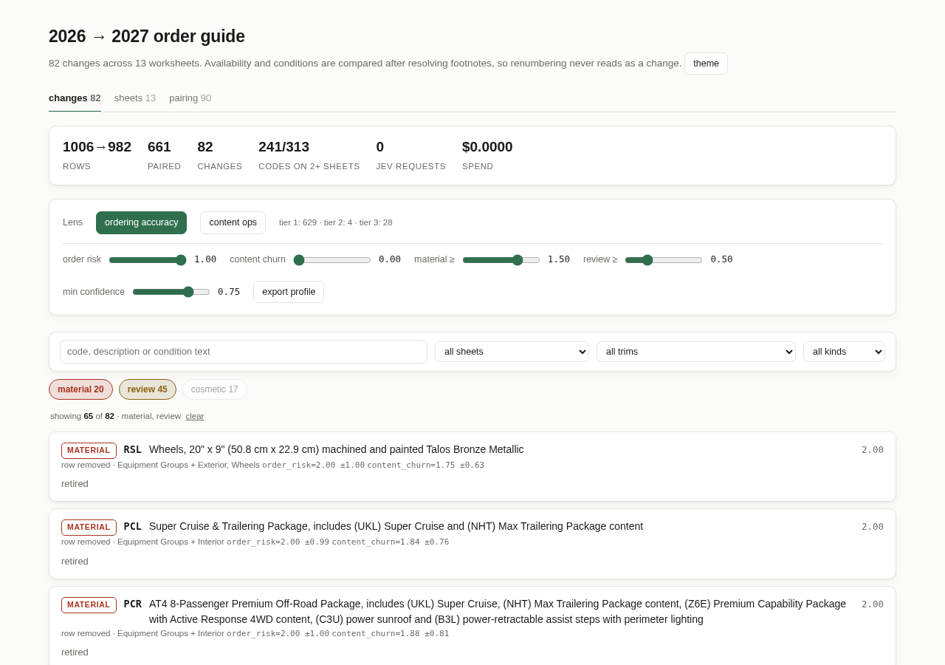
Figure 1. The report as it first opens, on the Changes tab.
Tab | Use it to…
changes | Work through the list of changes, most important first. This is where you will spend most of your time.
sheets | See a whole worksheet laid out like the paper page, with changed rows marked.
pairing | Check the rows the tool could not match up between the two years.

The number next to each tab is a count (82 changes, 13 sheets, 90 pairing items). The theme button next to the title switches between light and dark colors.

4.1 The Changes tab
From top to bottom the Changes tab has five parts.

Summary numbers
Rows shows how many rows each year has (1006 → 982). Paired is how many were matched. Changes is the total number of change cards. The other figures are for the administrator and can be ignored.

Lens and sliders
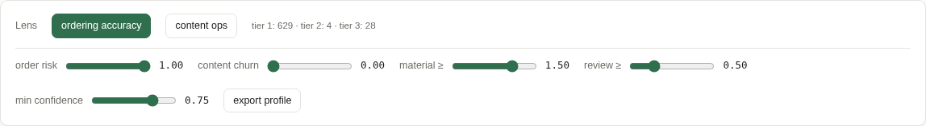
Figure 2. The lens buttons and sliders. Beginners can leave these alone.
These control how the changes are sorted into bands. You do not need to touch them. The default, ordering accuracy, puts first anything that changes what a dealer can order. If you want the opposite emphasis — what content was added or removed — click content ops. Moving a slider re-sorts the list instantly; nothing is re-run. To go back to the defaults, click the ordering accuracy button again.

Search box and filters
Type in the search box to find changes by option code (UKM), description (“wheel locks”) or condition text (“22-inch”). The three drop-downs narrow the list to one sheet, one trim or one kind of change.

Band buttons
The colored buttons under the search bar show how many changes are in each band, and switch each band on or off:
Band | What it means and what to do
material | Very likely to affect orders. Read every one.
review | Might matter. Read each one and decide.
cosmetic | Very unlikely to matter (wording tidied up, footnote reorganized). Hidden when the report opens — click the button to show them.
unjudged | Only appears if the run was done without ranking. Treat these as “review”.

Just above the first card, a line such as showing 65 of 82 · material, review tells you exactly which filters are on. Click clear to reset everything.

4.2 Reading a change card
Each change is a card. Here is a real one:
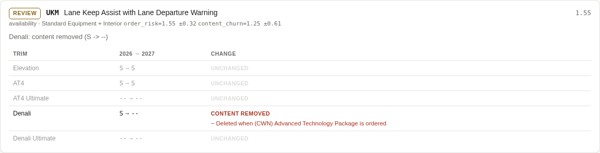
Figure 3. A change card: Lane Keep Assist removed from Denali.
Reading it from top left:
- Band (REVIEW) — how important the tool thinks this change is.
- Code and description (UKM, Lane Keep Assist with Lane Departure Warning) — the row in the order guide.
- Score (1.55, on the right) — the number the band comes from. Higher means more important. The list is sorted by this number.
- Kind and sheet (availability · Standard Equipment + Interior) — what type of change it is, and which sheet it is on. “+ Interior” means the same row also appears on the Interior sheet and changed the same way there, so you only need to read it once.
- Summary sentence (Denali: content removed (S -> --)) — the whole change in one line.
- Trim table — one line per trim showing last year → this year, and what changed. Unchanged trims are shown in grey so the changed ones stand out.
The small grey text after the sheet name (order_risk=1.55 ±0.32 …) shows the scores behind the band. You can ignore it.
In the trim table, lines starting with + (green) are conditions that were added this year, and lines starting with − (red) are conditions that were dropped. In the example above, Denali lost the feature, and the footnote “Deleted when (CWN) Advanced Technology Package is ordered” no longer applies.

Three more examples
A feature made available, plus a new condition. Wheel locks (SPZ) became available on Denali Ultimate (-- → A/D), and on every trim now require black lug nuts:
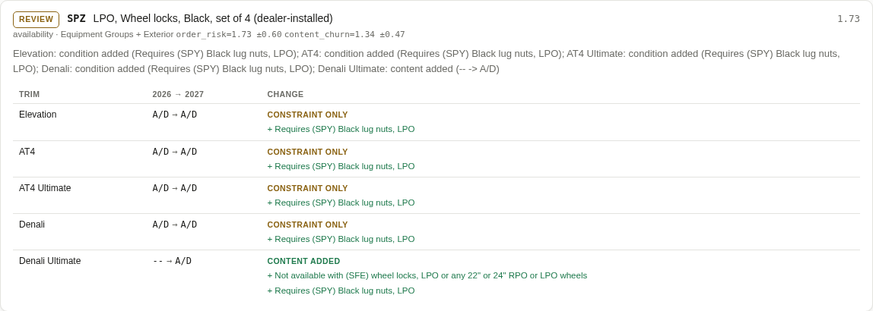
Figure 4. Content added on one trim, and a new condition on all trims.
A condition dropped. The Brembo brake upgrade (5JL) no longer requires 20″ or larger wheels on three trims. The symbol did not change (A/D → A/D), which is why this would be very easy to miss on paper:
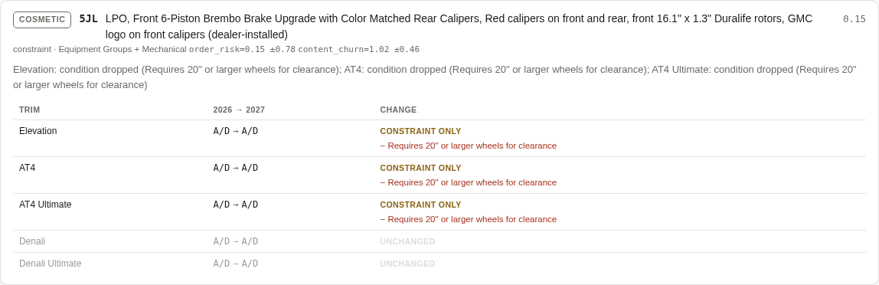
Figure 5. Only the condition changed. Denali and Denali Ultimate are unchanged.
A new row that may be a reworded old one. The line “needs review” at the bottom means the tool could not be sure whether this is a brand-new item or last year’s OnStar Basics row with new wording. Check the Pairing tab (Section 4.4).
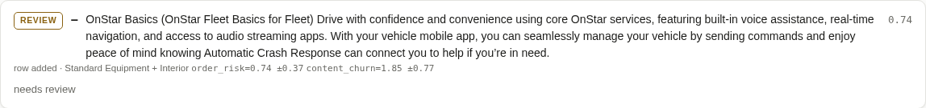
Figure 6. A row added this year, flagged for a human to confirm.
Tip
A card for a removed row just says retired: the option is gone this year. On the paper guide that was the row you could not find on the new printout.

4.3 The Sheets tab
The Sheets tab looks most like the paper order guide. Pick a sheet from the list on the left; the number next to each name is how many changed rows it has. Sheets are grouped into feature sheets, spec sheets and ratings.
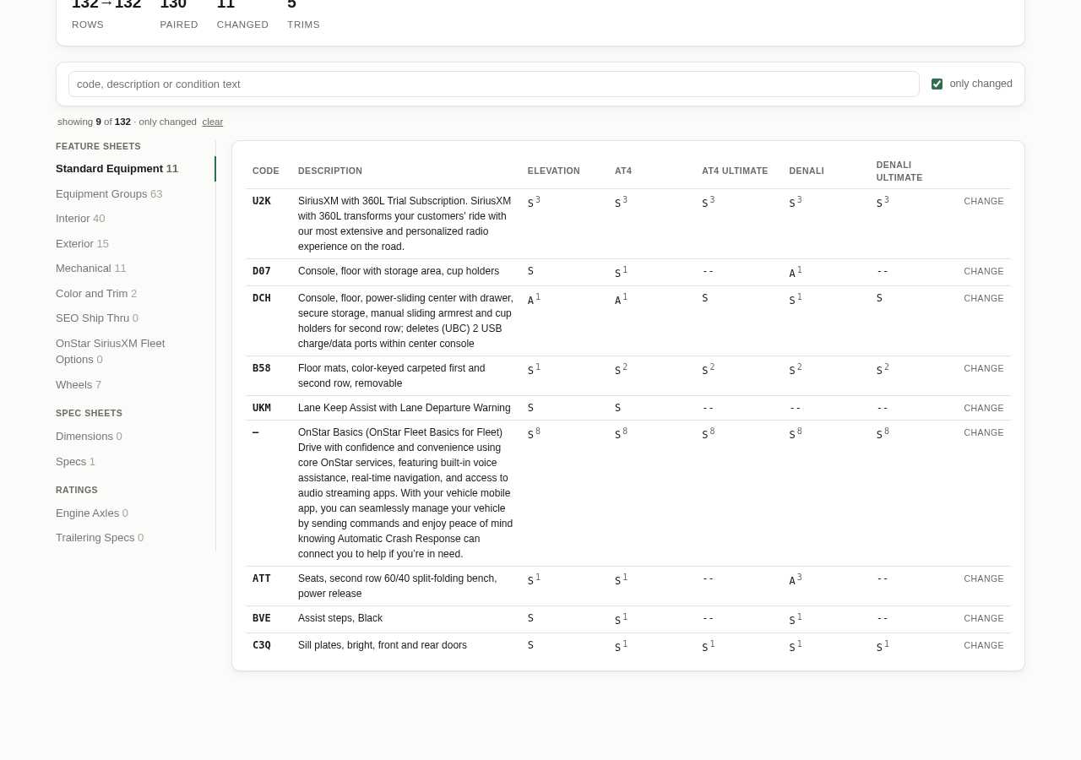
Figure 7. The Standard Equipment sheet with “only changed” ticked: 9 of 132 rows shown.
- Tick only changed to hide every row that did not change. This is the quickest way to review one sheet at a time, the way you used to go page by page.
- The small raised number after a symbol (S³) is the footnote number from this year’s guide, just as on the printout.
- Click CHANGE at the end of a row to jump to that row’s change card on the Changes tab.
- The search box works here too, and searches codes, descriptions and conditions.

4.4 The Pairing tab
Before it can compare anything, the tool has to line up each row from last year with the same row this year — the job you did by running a ruler down both printouts. It matches almost every row on its own. The Pairing tab lists the rows it could not simply match, grouped by reason:
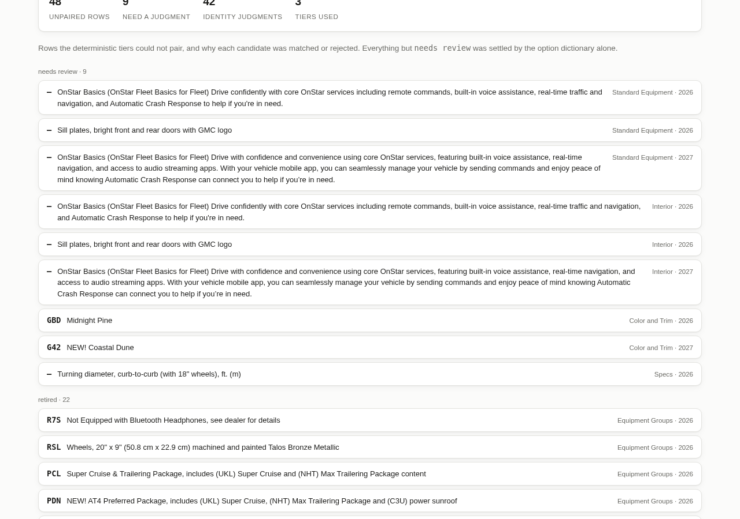
Figure 8. The Pairing tab. “needs review” is the group to check.
Group | What it means
needs review | The tool could not decide on its own. Look at these. They are usually the same feature with reworded text.
retired | The option exists last year only.
introduced | The option exists this year only.
moved off / onto sheet | The option is still offered but is listed on a different sheet this year.
listing removed / added | The option dropped off, or was added to, one sheet’s listing.

Each item shows the option code (or a dash), the description, and the sheet and year it came from. The Identity judgments table at the bottom shows how the tool decided on uncertain matches: pair (same row), unlink (different rows) or review (not sure). You normally do not need it.

5. The marked-up Excel workbook
If you used --annotate, you also have a copy of this year’s workbook with the changes marked. This is the closest thing to your old highlighted printout, and it is the easiest thing to send to colleagues who just want Excel.

5.1 The Change Log tab
A new first tab called Change Log lists every change, one line per changed cell. The columns are:
Column | What it holds
Band | material, review or cosmetic.
Score | The importance score. Sort this column from largest to smallest to put the most important changes at the top.
Kind | The kind of change (availability, constraint, …).
Code | The option code.
Sheet / Cell | Where the changed cell is — for example Standard Equipment, cell G14.
Trim | Which trim column.
Change | Old symbol → new symbol, and the type of change, for example “S -> -- (content removed)”.
Description | The row’s description.
Detail | Conditions added (+), dropped (−) or reworded (~).

Tip
The Change Log is not sorted by importance. Turn on Excel’s filter (Data → Filter), then filter Band to “material” or sort Score largest to smallest.

5.2 Colored cells
In the ordinary sheets, every changed cell is filled with a color that shows which way it changed. A legend is repeated at the bottom of the Change Log.
Color | Label | Meaning
 | content added | Was not available, now is.
 | content removed | Was available, now is not.
 | upgraded | Easier to get (for example optional → standard).
 | decontented | Harder to get (for example standard → optional).
 | package shift | Moved between ordered separately and part of a package.
 | fulfillment shift | Same availability, obtained differently (for example A → A/D).
 | constraint only | Same symbol, but its conditions changed.
 | incomparable | The trim does not exist in the other year.

Good to know
The color tells you the direction of a change, not how important it is. For importance, use the Band column or the report.
Pictures from the original workbook (such as wheel photographs) are not included in the marked-up copy. Keep the original export for those.
Rows that were removed entirely have no cell to color, so they appear only in the Change Log.

6. A recommended routine
This is a suggested replacement for the paper routine. It works through the changes from most to least important, so if you are interrupted, the important work is already done.
- Run the comparison (Section 3) and open the report.
- Material changes. On the Changes tab, click the review band button so only material is showing. Read every card. These are the changes most likely to affect orders.
- Review changes. Switch review back on and material off. Read each card and decide whether it matters for your team.
- Uncertain matches. Open the Pairing tab and look at the needs review group. Decide whether each pair is the same feature reworded or genuinely new or retired.
- One sheet at a time (optional). For sheets your team cares most about, open the Sheets tab, pick the sheet and tick only changed.
- Skim cosmetic changes (optional). Switch cosmetic on and scroll through quickly to confirm nothing important was classified as cosmetic.
- Share the results. Send colleagues the marked-up workbook and/or the report file (Section 7).
- Keep a record. Save the report and workbook with the two export files so the comparison can be looked at again later.

Stop doing | Start doing
Printing both years’ guides | Keeping the two .xlsx exports in the content folder
Decoding footnote numbers by hand | Reading the condition wording on each change card
Highlighting every changed cell | Using the colored cells in the marked-up workbook
Deciding from scratch which changes matter | Starting with material, then review
Retyping a change list for the team | Sending the Change Log tab or the report

7. Sharing and saving your place

7.1 Sending the report
The report is a single file, report.html. Send it by email, Teams or a shared drive like any other file. Your colleague double-clicks it to open it in their browser. They do not need the tool installed, an internet connection or an account.
Good to know
The report contains the order-guide content. Share it only with people who are allowed to see the order guide.

7.2 Pointing someone to a particular change
Everything you do in the report — the tab, the search text, the filters, the band buttons — is saved in the browser’s address bar, after the #. For example:
report.html#/changes?kind=availability
report.html#/sheets/standard-equipment?changed=1
- Bookmark the page to come back to the same view later.
- To show a colleague exactly what you are looking at, send them the report file and the part of the address from the # onwards. They open the file and paste that part at the end of the address.
- The browser’s Back button takes you to the previous tab.

8. Troubleshooting and common questions

8.1 Problems when running the command
What you see | What to do
refusing to under-report and a list of “FATAL” lines | The tool did not recognize the layout of one of the files and stopped rather than risk missing changes. Check that you are using the original GM export, unedited. If it still fails, send the message to your administrator.
No such file or directory | A file name is misspelled, or it has spaces and is missing its double quotes. Copy the name exactly from File Explorer.
No report.html or workbook was created | Check that the command includes --judge. The report and marked-up workbook are only written when it is present.
Lines starting with ERROR after “judged” | The ranking service could not be reached or the API key is missing. Ask your administrator to check the TypeSafe API key.
command not found: uv | The tool is not installed on this computer, or you are not in the project folder. See Section 3.3.

8.2 Questions about the results

A change I expected is missing.
First click the cosmetic band button — cosmetic changes are hidden when the report opens. Then click clear to remove any search text or filters. If it is still missing, the footnote number may have changed without its wording changing; the tool deliberately ignores that.

The same option appears on several sheets. Why is there only one card?
When the same row changes the same way on several sheets, the tool shows one card and lists the other sheets after a “+” (for example “Equipment Groups + Interior”). About three-quarters of option codes appear on more than one sheet, so this saves a lot of repeat reading.

The tool says an option was retired, but I can see it on another sheet this year.
The tool only matches rows within the same sheet. If an option moved to a different sheet, look for it in the moved off sheet / moved onto sheet groups on the Pairing tab.

Do I have to agree with the band?
No. The band is a suggestion to help you prioritize. You make the decision. That is why the tool shows the actual before-and-after symbols and conditions on every card.

Does running it again cost money?
Running the same two files again is free and instant. Only a new pair of files, or a new version of a file, is ranked again, and even then the cost is under one US cent.

Can the report be changed or edited?
No. The report is read-only. To record your decisions, add a notes column to the Change Log tab in the marked-up workbook.

Can I compare other GM vehicles?
Yes, provided both files are standard GM order-guide exports. Always put the older year first.

9. Quick reference

Run a comparison
cd ~/dev/projects/jev
uv run jev-diff compare "OLD.xlsx" "NEW.xlsx" \
--old-label 2026 --new-label 2027 \
--judge -o report.html --annotate 2027-annotated.xlsx
explorer.exe report.html

Bands
Band | Action
material | Read every one.
review | Read and decide.
cosmetic | Hidden by default; skim if you have time.

Report controls at a glance
Control | What it does
changes / sheets / pairing | Switch between the three views.
Search box | Find by code, description or condition text.
Sheet, trim, kind drop-downs | Narrow the list.
Band buttons | Show or hide material, review, cosmetic.
clear | Remove all searches and filters.
only changed (Sheets tab) | Hide unchanged rows.
CHANGE (Sheets tab) | Jump to that row’s change card.
ordering accuracy / content ops | Change the point of view used to rank. Default: ordering accuracy.
theme | Light or dark colors.

Reading a trim line
You see | It means
S → -- | Was standard, now not available.
-- → A/D | Was not available, now available dealer-installed.
A/D → A/D CONSTRAINT ONLY | Same availability; only the conditions changed.
+ Requires … | Condition added this year.
− Requires … | Condition dropped this year.
grey line, UNCHANGED | Nothing changed for this trim.

